
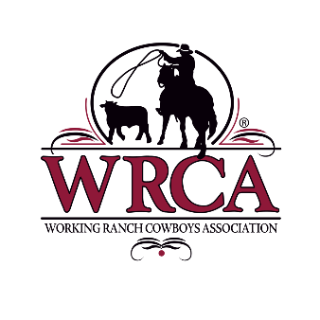
2021 Vendor Waitlist Form for WCRR
*For Non-Existing Vendors Only*
Name of Business or Individual
Contact
Mailing Address | Phone
 | Fax
 | Email

Please list all items sold/displayed (All vendors please submit pictures)
Absolutely NO SALE OF FIREARMS

Number of 10x10 booths requested (10x10 booth = $500):

References (List two with name, address, and phone number.)
1.
2.

Waitlist Deadline: September 1st, 2021

You will be contacted if selected as a 2021 vendor.
*Reminder: If selected, proof of liability insurance is required.
Waitlist forms must be completed every calendar year.

