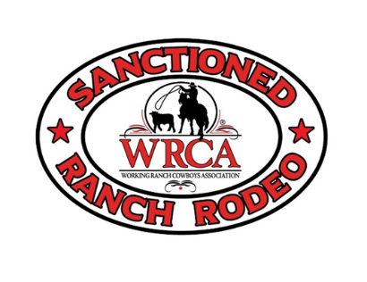

**Sandhills Classic  
WRCA Ranch Rodeo**

# **June 14th, 2024** Grant County Fairgrounds ~ East Hwy 2 ~ Hyannis, Nebraska

# **Entry deadline is April 1st. Entry Fee is $1000/team. Limited to 12 teams**

PLEASE SEND ENTRY FORM AND FEE TO HOLD YOUR SPOT. (Checks will not be deposited until May 1st.) TEAM CARD MUST BE PROVIDED BY MAY 15. IF MEMBERSHIP CARD IS NOT COMPLETE BY DEADLINE SPOT WILL GO TO NEXT ELIGIBLE TEAM.

**Team Name:**

If combining two ranches, please list ranch names separately:

**Ranch (1):**

Ranch Name:______________________________________

Ranch Manager:____________________________________ Brand:

Year Ranch was established:__________________________ Pronunciation of Brand:______________________________ Ranch Location:____________________________________

Operation, acreage, # of cows/yearlings:_________________ Contact Person:_________________________________________

Contact Address/Phone:___________________________________

Ranch Bio:

**Ranch (2):**

Ranch Name:______________________________________

Ranch Manager:____________________________________ Brand:

Year Ranch was established:__________________________ Pronunciation of Brand:______________________________ Ranch Location:____________________________________

Operation, acreage, # of cows/yearlings:__________________

Contact Person:__________________________________________

Contact Address/Phone:____________________________________

Ranch Bio:

**CONTESTANT INFORMATION**

Team Captain: ________________________________________________

Bronc Rider___________________________________________________

Contestant Name______________________________________________  
Phone __________________________Email________________________

Address______________________________________________________

Short Bio

Contestant Name______________________________________________  
Phone __________________________Email________________________

Address______________________________________________________

Short Bio

Contestant Name______________________________________________  
Phone __________________________Email________________________

Address______________________________________________________

Short Bio:

Contestant Name______________________________________________  
Phone __________________________Email________________________

Address______________________________________________________

Short Bio:

Contestant Name______________________________________________  
Phone __________________________Email________________________

Address______________________________________________________

Short Bio:

Contestant Name______________________________________________  
Phone __________________________Email________________________

Address______________________________________________________

Short Bio:

***\*\* Please include any ranch history and photos you may have so that we can include this information in our programs. If paper copies of photos are sent in, all photos will be returned to the team at check-in day of rodeo.***

**COPY OF WRCA TEAM CARD CAN BE MAILED OR EMAILED.

MUST HAVE PROOF OF CURRENT TEAM CARD (BY MAY 15) BEFORE ENTRY IS CONSIDERED COMPLETE!

**The SCRR Committee reserves the right to hold ½ of entry fee if team draws out before rodeo.**

Events: Stray Gathering, Team Branding, Sorting, Wild Cow Milking & Bronc Riding

Concessions will be on site. Pens around the arena are available, will have limited panels available to make pens. Eight Hookups available- first come, first serve.

Make entry fee check payable to: **Grant County Fairboard- Sandhills Classic**

**Mail form and entry fee to:**

McKenzie Minor

PO Box 301

Hyannis, NE 69350

**For more information;**

**308-760-2892 ~ mckenzieminor@yahoo.com**